**Data Visualization – COS30045**

**Weekly Report**

|  |  |
| --- | --- |
| **Assignment:** | **Lab Exercise Demonstration 1 (Exercises 1.1-2.4) (Week 3)** |
| **Student Name:** | Mai Hoang Dai Vy (104993201) |
| **Week 3** | |

**Week 1:**

*Lab 1_1.html:*

<!DOCTYPE html>

<html lang="en">

<head>

    <meta charset="UTF-8"/>

    <meta name="description"    content="Data Visualisation Exercise 1"/>

    <meta name="keywords"         content="HTML, CSS"/>

    <meta name="author"           content="Dai Vy"/>

    <title>Task 1.1 HTML and CSS Demo Page</title>

    <!--Insert description of exercise  -->

    <style>

    body {

        font-family: Arial, sans-serif;

        background: #f8f9fa;

        margin: 0;

        padding: 0 20px;

    }

    h1, h2 {

        color: #2c3e50;

    }

    figure {

        background: #fff;

        border: 1px solid #ddd;

        padding: 12px;

        margin: 24px 0;

        border-radius: 8px;

        text-align: center;

    }

    figcaption {

        font-size: 0.95em;

        color: #555;

        margin-top: 8px;

    }

    img {

        border-radius: 6px;

        margin: 0 8px;

        box-shadow: 0 2px 8px rgba(0,0,0,0.08);

    }

    .chart-buttons {

        margin-top: 12px;

        text-align: center;

    }

    .chart-buttons button {

        background: #3498db;

        color: #fff;

        border: none;

        padding: 10px 18px;

        margin: 0 6px;

        border-radius: 5px;

        font-size: 1em;

        cursor: pointer;

        transition: background 0.2s;

    }

    .chart-buttons button:hover {

        background: #217dbb;

    }

    </style>

</head>

<body>

    <h1>Title of Article about Interesting Visualisation</h1>

    <h2>Pet Comparison 2019 vs 2021</h2>

    <div>

        <p>

            A report from Animal Medicines Australia (AMA) has found that many Australians took the opportunity to introduce a pet into their household during the pandemic. Their survey indicated that there was a significant increase in the percent of households taking in a new dog, fish or bird. Their research also indicated that pets had a number of positive influences on their lives such as:

        </p>

        <ul>

            <li>Companionship</li>

            <li>Better mental health</li>

            <li>Joy and happiness</li>

        </ul>

        <p>Lorem ipsum, dolor sit amet consectetur adipisicing elit. Voluptatum fugit eos minus, hic ipsum animi reprehenderit sapiente, id odio, dicta nihil dolor et magnam? Totam temporibus consequuntur nemo odit beatae.</p>

    </div>

    <!-- Pet ownership data table image and source link -->

    <div>

        <figure>

            <img src="./pet_ownership_in_australia_table.png" alt="Pet ownership data table in Australia" style="max-width:100%;height:auto;">

            <figcaption>Australian Pet Ownership Data Sheet (Source: Animal Medicines Australia)</figcaption>

        </figure>

    </div>

    <p>Lorem ipsum, dolor sit amet consectetur adipisicing elit. Voluptatum fugit eos minus, hic ipsum animi reprehenderit sapiente, id odio, dicta nihil dolor et magnam? Totam temporibus consequuntur nemo odit beatae. Lorem ipsum dolor sit amet consectetur adipisicing elit. Repellat odio eum, nulla delectus a dolorem iure perferendis veniam id pariatur animi alias laudantium labore, aliquid aspernatur impedit dolor odit. Quae.

    </p>

    <footer>

        COS30045 Data Visualisation <br>

        Semester 2025 <br>

        Dai Vy

    </footer>

</body>

</html>

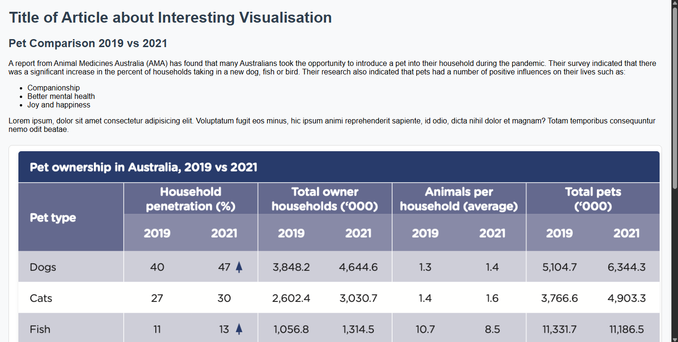

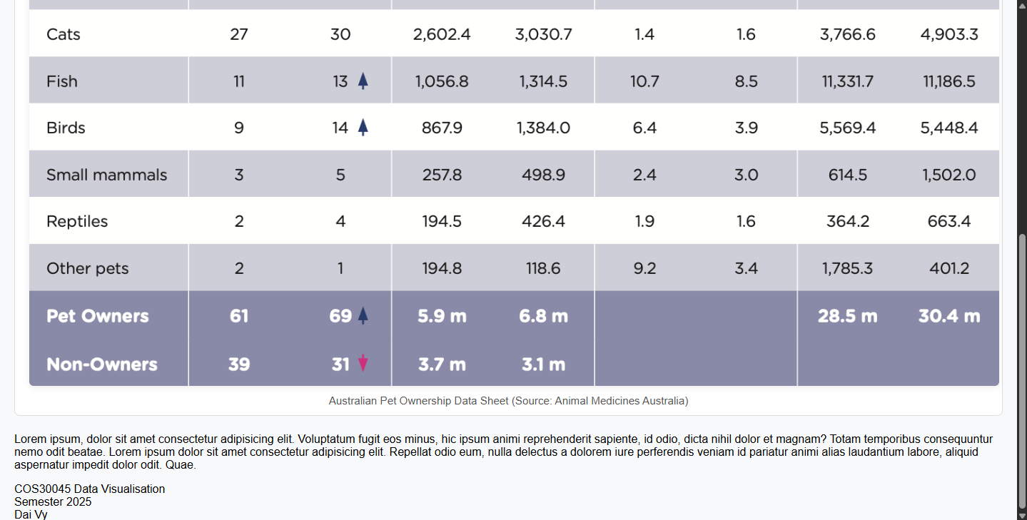

*Lab 1_2.html:*

<!DOCTYPE html>

<html lang="en">

<head>

    <meta charset="UTF-8"/>

    <meta name="description"    content="Data Visualisation Exercise 1"/>

    <meta name="keywords"         content="HTML, CSS"/>

    <meta name="author"           content="Dai Vy"/>

    <title>Task 1.1 HTML and CSS Demo Page</title>

    <!--Insert description of exercise  -->

    <style>

    body {

        font-family: Arial, sans-serif;

        background: #f8f9fa;

        margin: 0;

        padding: 0 20px;

    }

    h1, h2 {

        color: #2c3e50;

    }

    figure {

        background: #fff;

        border: 1px solid #ddd;

        padding: 12px;

        margin: 24px 0;

        border-radius: 8px;

        text-align: center;

    }

    figcaption {

        font-size: 0.95em;

        color: #555;

        margin-top: 8px;

    }

    img {

        border-radius: 6px;

        margin: 0 8px;

        box-shadow: 0 2px 8px rgba(0,0,0,0.08);

    }

    .chart-buttons {

        margin-top: 12px;

        text-align: center;

    }

    .chart-buttons button {

        background: #3498db;

        color: #fff;

        border: none;

        padding: 10px 18px;

        margin: 0 6px;

        border-radius: 5px;

        font-size: 1em;

        cursor: pointer;

        transition: background 0.2s;

    }

    .chart-buttons button:hover {

        background: #217dbb;

    }

    </style>

</head>

    <script>

        const charts = [

            {

                src: "Pets_2019.png",

                alt: "Pet ownership in 2019",

                caption: "Fig 1: Pet ownership in 2019"

            },

            {

                src: "Pets_2021.png",

                alt: "Pet ownership in 2021",

                caption: "Fig 2: Pet ownership in 2021"

            },

            {

                src: "Both.png",

                alt: "Comparison of pet ownership in 2019 and 2021",

                caption: "Fig 3: Comparison of pet ownership in 2019 and 2021"

            }

        ];

        function showChart(index) {

            const img = document.getElementById('chart-img');

            const caption = document.getElementById('chart-caption');

            img.src = charts[index].src;

            img.alt = charts[index].alt;

            caption.textContent = charts[index].caption;

        }

    </script>

<body>

    <h1>Title of Article about Interesting Visualisation</h1>

    <h2>Author of Interesting Article</h2>

    <h3>Drawing Shape with SVG</h3>

    <div>

        <p>

            A report from Animal Medicines Australia (AMA) has found that many Australians took the opportunity to introduce a pet into their household during the pandemic. Their survey indicated that there was a significant increase in the percent of households taking in a new dog, fish or bird. Their research also indicated that pets had a number of positive influences on their lives such as:

        </p>

        <ul>

            <li>Companionship</li>

            <li>Better mental health</li>

            <li>Joy and happiness</li>

        </ul>

        <p>Lorem ipsum, dolor sit amet consectetur adipisicing elit. Voluptatum fugit eos minus, hic ipsum animi reprehenderit sapiente, id odio, dicta nihil dolor et magnam? Totam temporibus consequuntur nemo odit beatae.</p>

    </div>

    <p>Lorem ipsum, dolor sit amet consectetur adipisicing elit. Voluptatum fugit eos minus, hic ipsum animi reprehenderit sapiente, id odio, dicta nihil dolor et magnam? Totam temporibus consequuntur nemo odit beatae. Lorem ipsum dolor sit amet consectetur adipisicing elit. Repellat odio eum, nulla delectus a dolorem iure perferendis veniam id pariatur animi alias laudantium labore, aliquid aspernatur impedit dolor odit. Quae.

    </p>

    <div id="chart-section">

        <figure>

            <img id="chart-img" style="max-width:100%;height:auto;">

            <figcaption id="chart-caption"></figcaption>

        </figure>

        <div class="chart-buttons">

            <p>Search data for each year here:</p>

            <button onclick="showChart(0)">2019</button>

            <button onclick="showChart(1)">2021</button>

            <button onclick="showChart(2)">Both</button>

        </div>

    </div>

    <footer>

        COS30045 Data Visualisation <br>

        Semester 2025 <br>

        Dai Vy

    </footer>

</body>

</html>

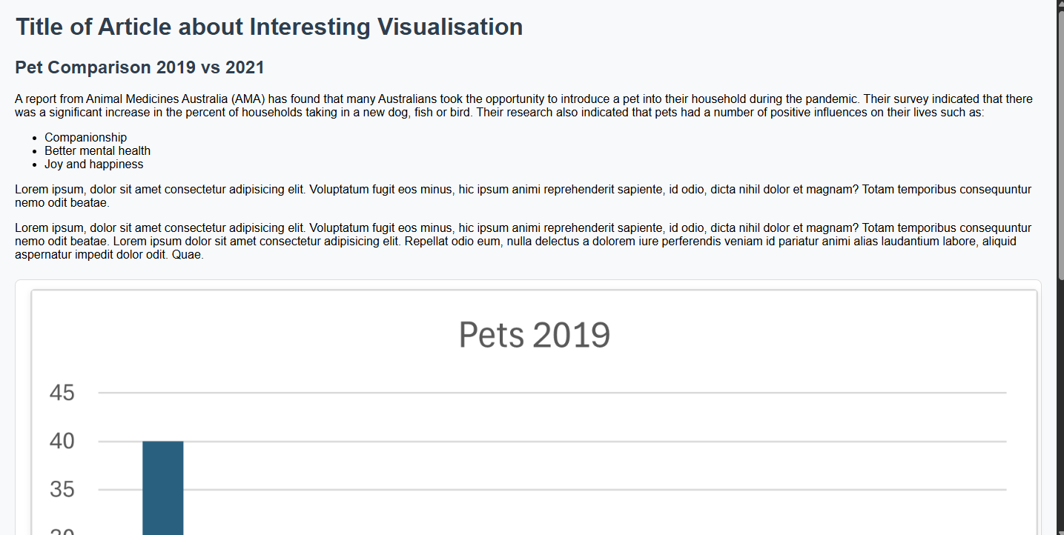

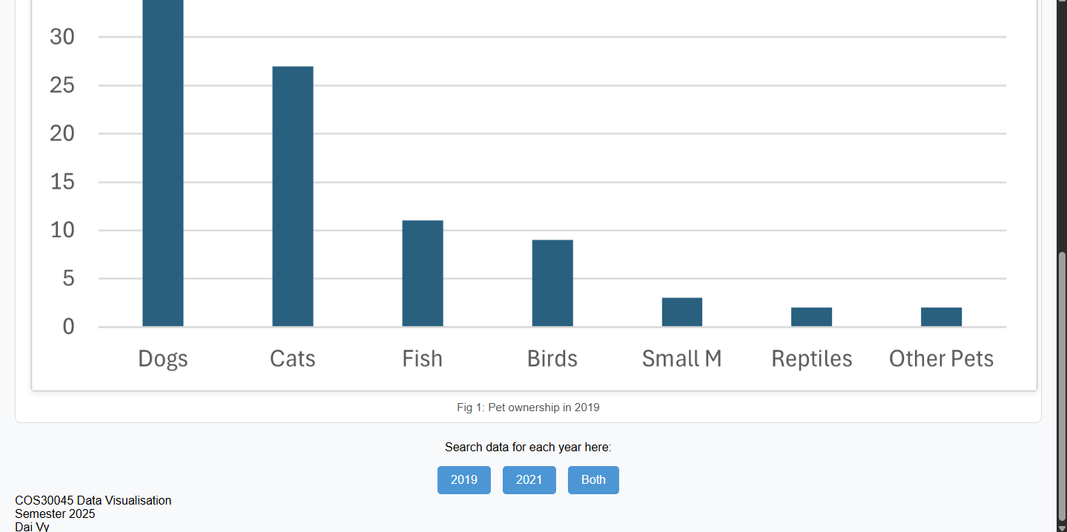

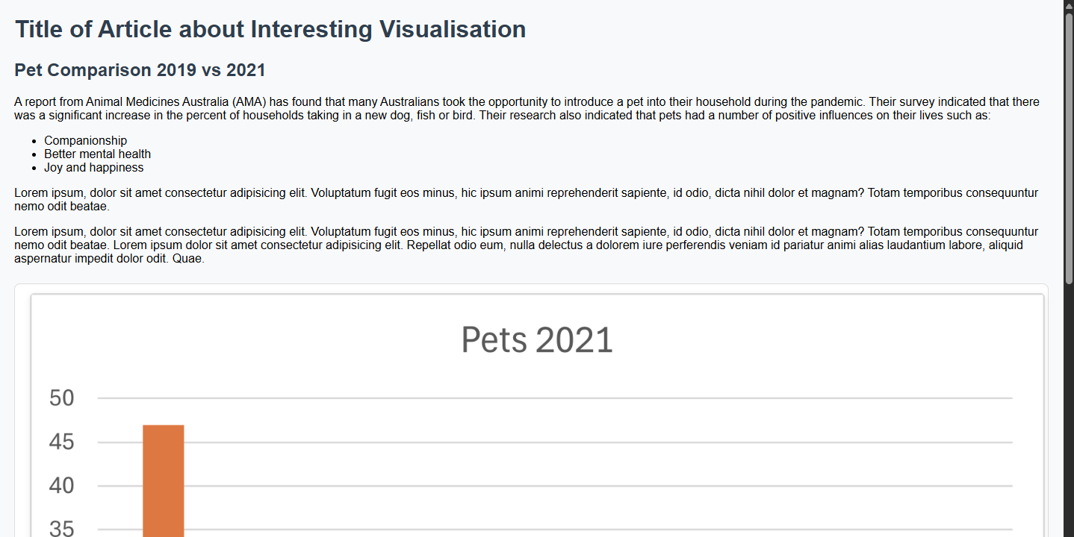

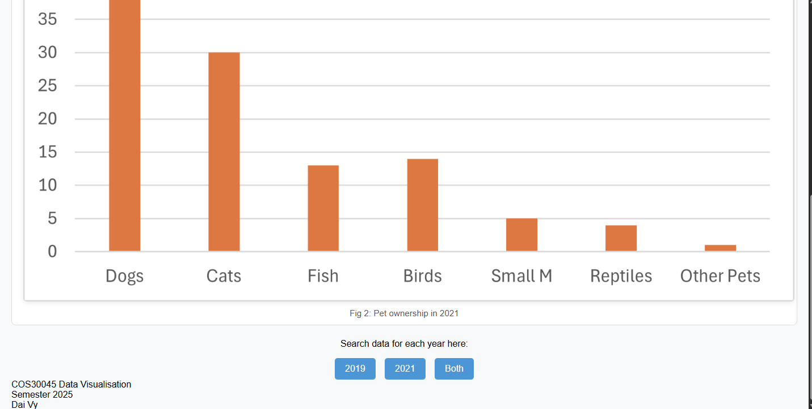

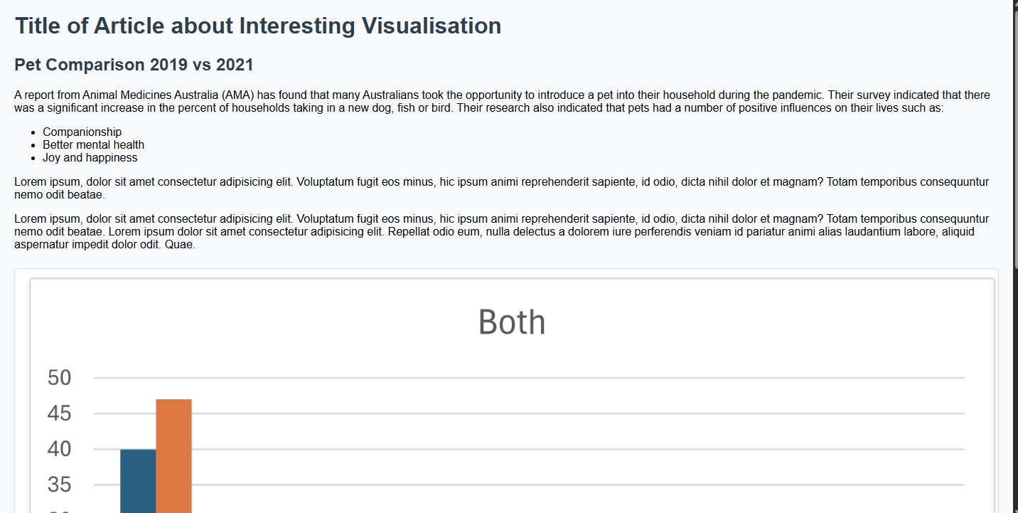

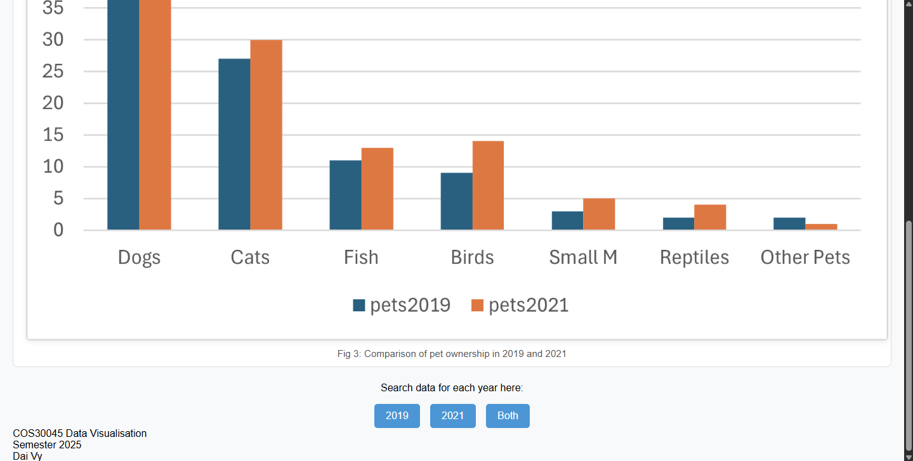

*Lab 1_3.html:*

<!DOCTYPE html>

<html lang="en">

<head>

    <meta charset="UTF-8"/>

    <meta name="description"    content="Data Visualisation Exercise 1"/>

    <meta name="keywords"         content="HTML, CSS"/>

    <meta name="author"           content="Dai Vy"/>

    <title>Task 1.1 HTML and CSS Demo Page</title>

    <!--Insert description of exercise  -->

    <style>

        body {

            font-family: 'Segoe UI', Arial, sans-serif;

            background: #f8f9fa;

            margin: 0;

            padding: 0 20px;

            min-height: 100vh;

            display: flex;

            flex-direction: column;

        }

        h1 {

            color: #2c3e50;

            text-align: center;

            margin-top: 32px;

            margin-bottom: 24px;

            letter-spacing: 1px;

        }

        div {

            display: flex;

            flex-direction: column;

            align-items: center;

            gap: 32px;

            margin-bottom: 40px;

        }

        svg {

            box-shadow: 0 4px 16px rgba(44, 62, 80, 0.08);

            margin-bottom: 8px;

            transition: box-shadow 0.2s;

            background: #fff;

        }

        svg:hover {

            box-shadow: 0 8px 32px rgba(44, 62, 80, 0.18);

        }

        footer {

            text-align: left    ;

            color: #888;

            font-size: 1em;

            margin-top: auto;

            padding: 16px 0;

            border-top: 1px solid #e1e1e1;

            background: #f1f1f1;

            border-radius: 0 0 10px 10px;

        }

    </style>

</head>

<body>

    <h1>Drawing SVG Shapes</h1>

    <div>

        <svg width="500" height="50" style="background-color:slategrey;">

            <g transform="translate(20, 0)">

                <circle cx="25", cy="25", r="25", fill="cornflowerblue" />

                <rect x="50" ,y="5", width="50", height="50", fill="rgb(100, 149, 237)" />

                <ellipse cx="140", cy="30", rx="40", ry="25", fill="rgba(100, 149, 237, 0.5)" />

                <Line x1="0", y1="30", x2="180", y2="30", stroke="black", stroke-width="5" />

            </g>

        </svg><br>

        <svg width="500" height="200" style="background-color: slategrey;">

            <g transform="translate(20, 0)">

                <rect x="0" y="20" width="50" height="160" fill="rgb(100, 149, 237, 1)"/>

                <rect x="60" y="60" width="50" height="120" fill="rgb(100, 149, 237, 1)"/>

                <rect x="120" y="100" width="50" height="80" fill="rgb(100, 149, 237, 1)"/>

                <rect x="180" y="140" width="50" height="40" fill="rgb(100, 149, 237, 1)"/>

                <rect x="240" y="170" width="50" height="10" fill="rgb(100, 149, 237, 1)"/>

            </g>

        </svg>

    </div>

    <footer>

        COS30045 Data Visualisation <br>

        Semester 2025 <br>

        Dai Vy

    </footer>

</body>

</html>

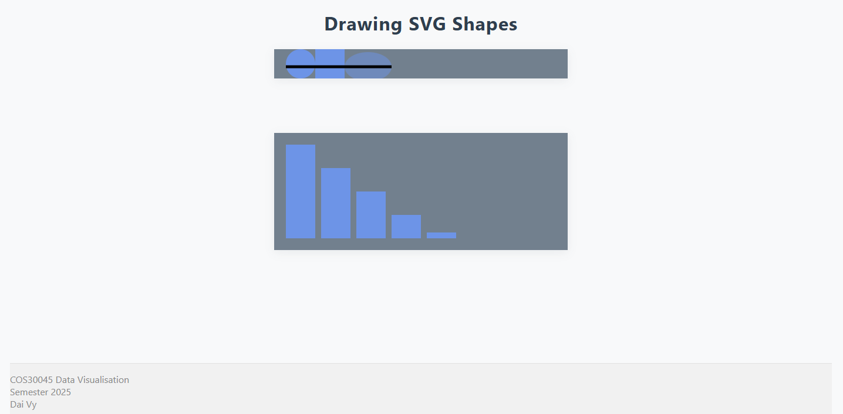

**Week 2:**

*Lab 2_1.html:*

<!DOCTYPE html>

<html lang="en">

<head>

    <meta charset="UTF-8">

    <meta name="description" content="Data Visualization"/>

    <meta name="keywords" content="HTML, CSS, D3"/>

    <meta name="author" content="Dai Vy"/>

    <title>Task 2.1 D3 Data Binding</title>

    <script src="https://d3js.org/d3.v7.min.js"></script>

    <style>

        .warning {

            color: red;

        }

    </style>

</head>

<body>

    <h1>The D3 Journey starts here...</h1>

    <script>

        var dataset = [14, 5, 26, 23, 9];

            d3.select("body").selectAll("p")

                .data(dataset)

                .enter()

                .append("p")

                .attr("class", function(d)

                {

                    if (d > 10)

                    {

                        return "warning";

                    }

                })

                .text(function(d) {

                    if (d < 10)

                    {

                        return "Joe watched " + d + " cat videos today";

                    }

                    else

                    {

                        return "Warning: Joe watched " + d + " cat videos this month";

                    }

                });

    </script>

    <br>

    <footer style="color: grey">COS30045 Data Visualization<br>

        Dai Vy

    </footer>

</body>

</html>



*Lab 2_2.html:*

<!DOCTYPE html>

<html lang="en">

<head>

    <meta charset="UTF-8">

    <meta name="description" content="Data Visualization"/>

    <meta name="keywords" content="HTML, CSS, D3"/>

    <meta name="author" content="Dai Vy"/>

    <title>Task 2.2 D3 Bar Chart</title>

    <script src="https://d3js.org/d3.v7.min.js"></script>

    <style>

    </style>

</head>

<body>

    <h1>The D3 Journey starts here...</h1>

    <script>

        var w = 500;

        var h = 100;

        var padding = 1;

        var dataset = [14, 5, 26, 23, 9, 12, 8, 18, 20, 15];

        var svg = d3.select("body")

            .append("svg")

            .attr("width", w)

            .attr("height", h);

        svg.selectAll("rect")

            .data(dataset)

            .enter()

            .append("rect")

            .attr("x", function(d, i) {

                return i * (w / dataset.length);

            })

            .attr("y", function(d) {

                return h - d * 4;

            })

            .attr("width", w / dataset.length - padding)

            .attr("height", function(d) {

                return d * 4;

            })

            .attr("fill", "steelblue")

        svg.selectAll("text")

            .data(dataset)

            .enter()

            .append("text")

            .text(function(d) {

                return d; // This displays the number on each bar

            })

            .attr("x", function(d, i) {

                return i * (w / dataset.length) + ((w / dataset.length - padding) / 2);

            })

            .attr("y", function(d) {

                return h - (d * 4) / 2;

            })

            .attr("text-anchor", "middle")

            .attr("fill", "white")

            .attr("font-size", "12px");

    </script>

    <br>

    <footer style="color: grey">COS30045 Data Visualization<br>

        Dai Vy

    </footer>

</body>

</html>

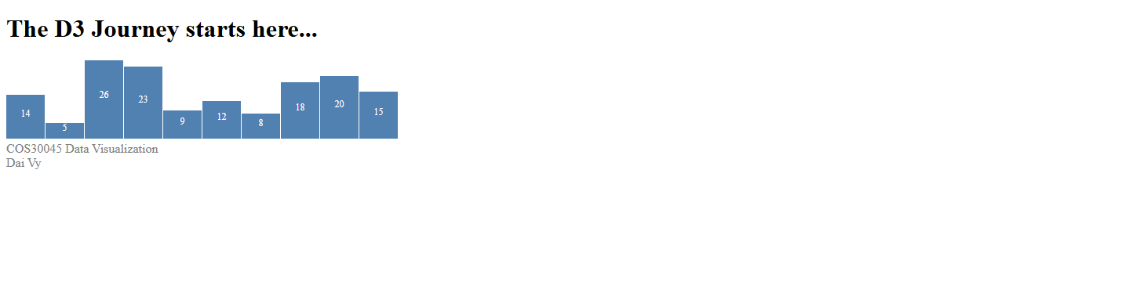

*Lab 2_3.html:*

<!DOCTYPE html>

<html lang="en">

<head>

    <meta charset="UTF-8">

    <meta name="description" content="Data Visualization"/>

    <meta name="keywords" content="HTML, CSS, D3"/>

    <meta name="author" content="Dai Vy"/>

    <title>Task 2.3 D3 Scatter Plot</title>

    <script src="https://d3js.org/d3.v7.min.js"></script>

    <style>

    </style>

</head>

<body>

    <h1>The D3 Journey starts here...</h1>

    <script>

        var w = 700;

        var h = 200;

        var dataset = [

            [5, 20],

            [480, 90],

            [250, 50],

            [100, 33],

            [330, 95],

            [410, 12],

            [475, 44],

            [25, 67],

            [85, 21],

            [220, 88]

        ];

        var svg = d3.select("body")

            .append("svg")

            .attr("width", w)

            .attr("height", h);

        svg.selectAll("circle")

            .data(dataset)

            .enter()

            .append("circle")

            .attr("cx", function(d, i) {

                return d[0];

            })

            .attr("cy", function(d) {

                return d[1];

            })

            .attr("r", function(d) {

                return d[1] / 5; // Scale down for reasonable circle size

            })

            .attr("fill", function(d) {

                // Highlight important points in red if y-value > 80

                return d[1] > 80 ? "red" : "slategrey";

            });

        svg.selectAll("text")

            .data(dataset)

            .enter()

            .append("text")

            .attr("x", function(d, i) {

                return d[0];

            })

            .attr("y", function(d) {

                return d[1];

            })

            .text(function(d) {

                return d[0] + "," + d[1];

            })

            .attr("font-family", "sans-serif")

            .attr("font-size", "11px")

            .attr("fill", "black")

    </script>

    <br>

    <footer style="color: grey">COS30045 Data Visualization<br>

        Dai Vy

    </footer>

</body>

</html>

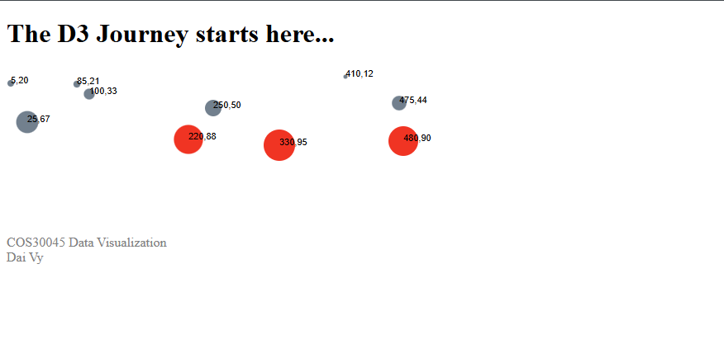

*Lab 2_4.html:*<!DOCTYPE html>

<html lang="en">

<head>

    <meta charset="UTF-8"/>

    <meta name="description" content="Data Visualisation"/>

    <meta name="keyword" content="HTML, CSS, D3"/>

    <meta name="author" content="Dai Vy"/>

    <title>Task 2.4 D3 Loading Data with CSV</title>

    <script src="https://d3js.org/d3.v7.min.js"></script>

    <script src="/Lab 2.4/Lab 2_4.js"></script>

</head>

<body>

    <h1>The D3 Journey starts here...</h1>

    <p id="chart"></p>

    <br>

    <bf></bf>

    <footer style="color: grey">COS30045 Data Visualization<br>

        Dai Vy</footer>

</body>

</html>

*Lab 2_4.js:*

function init(){

    var w = 700;

    var h = 150;

    var barPadding = 2;

    d3.csv("Task_2_4_data.csv").then(function(data) {

        console.log(data);

        wombatSightings = data;

        barChart(wombatSightings);

    });

    var svg = d3.select("#chart")

                .append("svg")

                .attr("width", w)

                .attr("height", h);

    function barChart() {

        svg.selectAll("rect")

        .data(wombatSightings)

        .enter()

        .append("rect")

        .attr("x", function(d, i){

            return i * (w/wombatSightings.length);

        })

        .attr("y", function(d){

            return h - (d.wombats*4);

        })

        .attr("width", (w/wombatSightings.length)-barPadding)

        .attr("height", function(d){

            return d.wombats*4;

        })

        .attr("fill", function(d){

            return d.wombats > 10 ? "darkblue" : "lightblue";

        })

        .on("mouseover", function(event, d, i) {

            // Highlight bar

            d3.select(this).attr("fill", "orange");

            // Add text on the bar

            svg.append("text")

                .attr("class", "bar-label")

                .attr("x", +d3.select(this).attr("x") + (+d3.select(this).attr("width")/2))

                .attr("y", +d3.select(this).attr("y") - 5)

                .attr("text-anchor", "middle")

                .attr("font-size", "12px")

                .attr("fill", "black")

                .text(d.wombats);

        })

        .on("mousemove", function(event) {

            d3.select("#tooltip")

                .style("left", (event.pageX + 10) + "px")

                .style("top", (event.pageY - 20) + "px");

        })

        .on("mouseout", function(event, d) {

            d3.select(this).attr("fill", d.wombats > 10 ? "darkblue" : "lightblue");

            svg.selectAll(".bar-label").remove();

        });

    }

}

window.onload = init;

